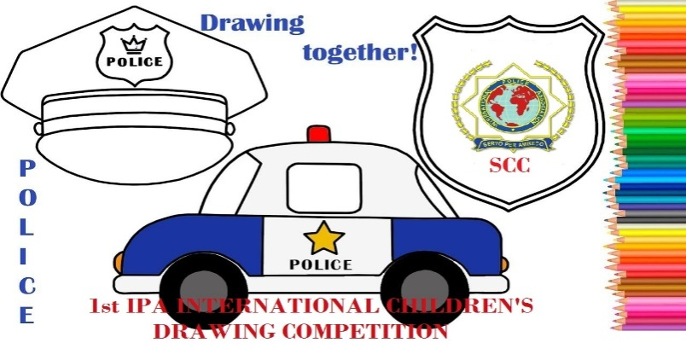 | INTERNATIONAL POLICE ASSOCIATION  INTERNATIONAL EXECUTIVE BOARD  SOCIO-CULTURAL COMMISSION  3rdIPA INTERNATIONAL CHILDREN’S  DRAWING COMPETITION
ENTRY FORM
Member’s name: ___________________________________________________
Member’s IPA card no: ______________________________________________
Relation with the child: ______________________________________________
Child’s name: ______________________________________________________
Child’s date of birth: ________________________________________________
Section: __________________________________________________________
Topics of the painting: (please tick)
Police in my home town
Police cars
Friendship
GUARDIAN’S CONTACT DETAILS
Address: __________________________________________________________
Mobile tel. number: ________________________________________________
e-mail: ___________________________________________________________
By signing below, I hereby declare that the above information is true and by posting this entry I have read and accept the terms of the competition.

Date___________Place_____________Signature__________
ENTRIES RECEIVED LATER THAN 31-8-2023 WILL BE REJECTED
Please scan and sign this form and send it together with the painting scanned, to ipa.icpc@gmail.com

